Credit Risk Copilot
Agentic Workflow Plan: traditional scoring + LLM analysis of unstructured data
IS4000 group project, UBS Challenge 3: Credit Risk Assessment. Draft for group review, 14 Oct 2026.

1. Summary
UBS Challenge 3 asks for a model that uses LLMs to analyse unstructured data (customer reviews, social media posts, news articles) to assess creditworthiness, and that complements traditional credit scoring.
Our answer is a three-phase workflow, run by an orchestrator for a credit analyst:
- Phase 1, Traditional Scoring: the bank's existing approach (financial ratios, credit history, repayment data) produces a Traditional Score (0–100). We do not replace it.
- Phase 2, Agentic Unstructured Data Analysis: specialist agents read reviews, social media and news in parallel. An LLM aggregates and cross-checks their findings into an Unstructured Score (0–100) with a written rationale.
- Phase 3, Combine and Classify: a weighted blend (default 70% traditional, 30% unstructured) gives a Final Composite Score, classified as LOW (70 or more), MEDIUM (40–69) or HIGH (below 40) risk.
The analyst receives the risk rating, the final score, the breakdown of both scores and the LLM rationale, and makes the credit decision.
The worked example throughout is an SME credit request. The same three phases extend to all industries and company sizes, from thin-file individuals and home-based businesses to large corporates, by changing the configuration of each phase (section 6).
How it complements traditional scoring
Traditional scoring answers: "What do the numbers say?"
The agentic workflow answers: "What do the numbers miss, and what is the evidence?" For example: a wave of customer complaints, litigation, a key customer leaving, a controversy, or positive signals such as expansion and strong repeat-customer reviews.
The analyst gets both, side by side, with a rationale they can check, and keeps the final decision.

What is in this document
- Section 2: the envisioned workflow (our sequence diagram) and a step-by-step walkthrough.
- Section 3: where the agentic workflow sits within a traditional credit assessment.
- Section 4: component specification for each participant in the diagram.
- Section 5: recommended refinements, for the group to accept or reject.
- Sections 6–10: scaling to all segments, reuse from IS445, evaluation, build plan, risks.

2. The envisioned workflow
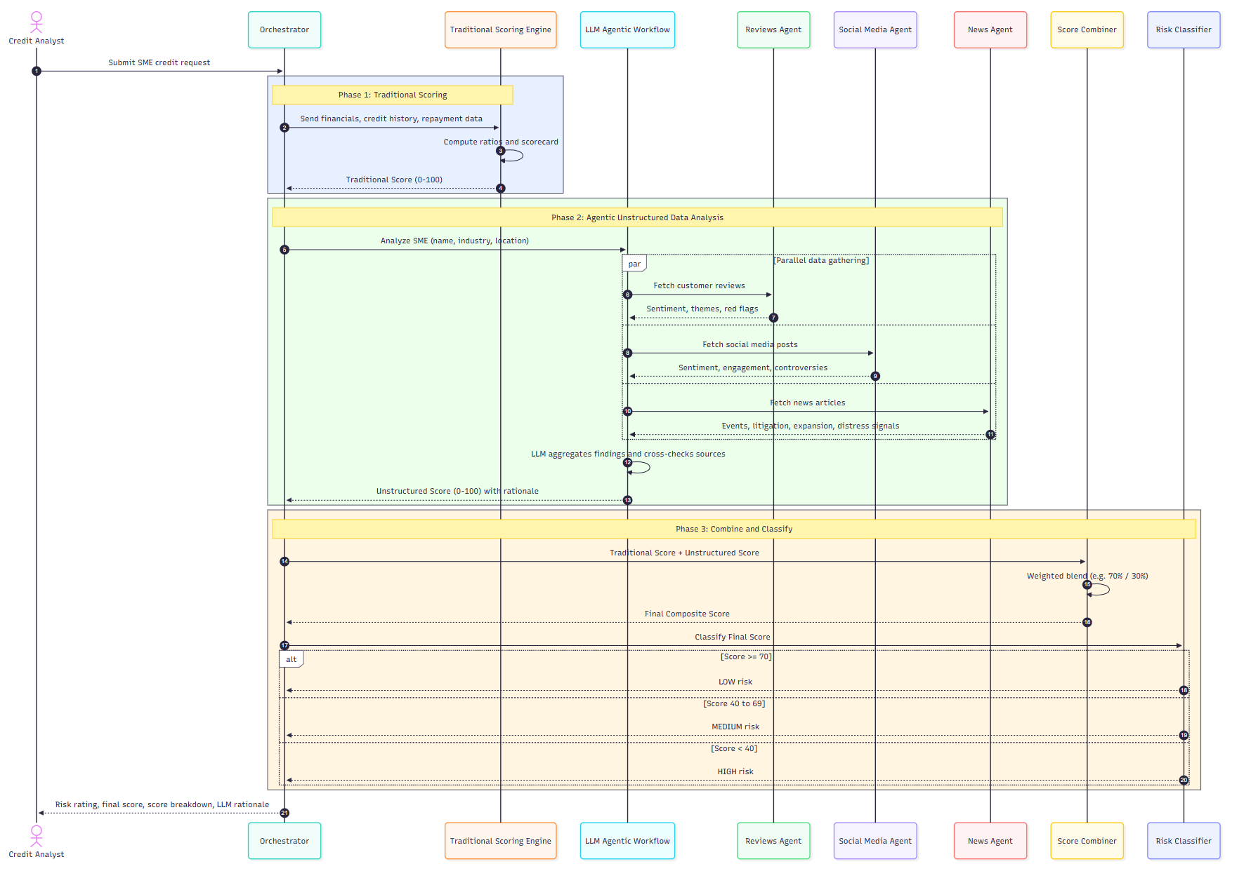
Figure 1. Envisioned sequence: Phase 1 Traditional Scoring, Phase 2 Agentic Unstructured Data Analysis, Phase 3 Combine and Classify (SME example).

2.1 Step-by-step walkthrough
Step | Phase | From → To | What happens | Notes
1 | Intake | Credit Analyst → Orchestrator | Submit SME credit request | Application, consent and company identifiers (name, UEN, industry, location).
2 | Phase 1 | Orchestrator → Traditional Scoring Engine | Send financials, credit history, repayment data | Structured data only.
3 | Phase 1 | Traditional Scoring Engine | Compute ratios and scorecard | Current, quick, debt/equity, interest cover; bureau and repayment points.
4 | Phase 1 | Traditional Scoring Engine → Orchestrator | Traditional Score (0–100) | Plus the individual ratio results and reason codes.
5 | Phase 2 | Orchestrator → LLM Agentic Workflow | Analyze SME (name, industry, location) | Starts the unstructured analysis.
6–7 | Phase 2 | Workflow ↔ Reviews Agent | Fetch customer reviews → sentiment, themes, red flags | Runs in parallel with steps 8–11.
8–9 | Phase 2 | Workflow ↔ Social Media Agent | Fetch social media posts → sentiment, engagement, controversies | Public business accounts only.
10–11 | Phase 2 | Workflow ↔ News Agent | Fetch news articles → events, litigation, expansion, distress signals | Adverse and positive events.
12 | Phase 2 | LLM Agentic Workflow | Aggregate findings and cross-check sources | Removes duplicates, resolves conflicts, checks claims against at least one other source.
13 | Phase 2 | LLM Agentic Workflow → Orchestrator | Unstructured Score (0–100) with rationale | Rationale cites the evidence items.
14 | Phase 3 | Orchestrator → Score Combiner | Traditional Score + Unstructured Score
15 | Phase 3 | Score Combiner | Weighted blend (e.g. 70% / 30%) | Deterministic Python.
16 | Phase 3 | Score Combiner → Orchestrator | Final Composite Score
17 | Phase 3 | Orchestrator → Risk Classifier | Classify final score
18–20 | Phase 3 | Risk Classifier → Orchestrator | LOW (70 or more) / MEDIUM (40–69) / HIGH (below 40) | Same bands as the design doc scorecard.
21 | Analyst | Orchestrator → Credit Analyst | Risk rating, final score, score breakdown, LLM rationale | The analyst reviews and decides.

3. Where the agentic workflow sits in a traditional credit assessment
Stage names follow the IS445 corporate lending lifecycle and the professor's Four Parts of credit evaluation. The Diagram phase column shows which part of Figure 1 does the work. Impact shows how much the agentic workflow changes the stage.
Impact key: Unchanged traditional method kept Assist agents support the analyst Major agents do most of the work, a human signs off
# | Traditional stage | Today | What the agentic workflow adds | Diagram phase | Impact
1 | Application and intake | A clerk checks forms and chases missing documents | Orchestrator validates the request, checks consent, lists data gaps | Intake (step 1) | Assist
2 | KYC / AML / sanctions | Operations runs screening tools | News Agent adds adverse-media screening on the company and its directors; sanctions screening is unchanged | Phase 2 | Assist
3 | Data gathering | An analyst collects financials, the bureau report and statements | Agents fetch reviews, posts and news automatically | Phase 2 (steps 6–11) | Major
4 | Quantitative analysis (Part 2: ratios) | The analyst spreads the numbers and runs the scorecard or ratio model | Unchanged. The bank's own model is the Traditional Scoring Engine | Phase 1 (steps 2–4) | Unchanged
5 | Cash-flow analysis (Part 3) | Manual review of statements | Optional extension: a cash-flow agent tags bank-statement transaction (thin-file segments) | Phase 2 (extension) | Assist
6 | Qualitative assessment (Part 1: management, industry, reputation, conduct) | The relationship manager fills a judgement scorecard from memory and meetings. Slowest and least consistent step | Main role. Reviews, social and news evidence is scored and cross-checked, with a cited rationale | Phase 2 (steps 12–13) | Major
7 | Projections (Part 4) | The analyst builds forecasts | News signals (expansion, distress, lost customers) flag optimistic assumptions | Phase 2 → analyst | Assist
8 | Risk rating | Quantitative rating plus a manual overlay | Weighted blend and classifier produce LOW / MEDIUM / HIGH with a breakdown | Phase 3 (steps 14–20) | Major
9 | Credit memo | The analyst writes 5–20 pages | The LLM rationale becomes the first draft of the qualitative section | Step 21 → analyst | Major
10 | Approval / credit committee | Tier routing and dual review | Rating and breakdown route the case: LOW to fast track, HIGH to senior review | Analyst | Assist
11 | Structuring and pricing | Relationship manager and credit team negotiate | Red flags inform covenants and pricing | Analyst | Assist
12 | Documentation and disbursement | Legal and operations | Out of scope | — | Out of scope
13 | Monitoring and annual review | Review every 12 months | Re-run Phase 2 on a schedule; alert when the Unstructured Score drops sharply (early warning) | Phase 2 (re-run) | Major
14 | Watchlist and workout | Special-assets team | Evidence file from the agents | Phase 2 | Assist

Takeaway: Phase 1 keeps the traditional score exactly as the bank runs it today (stage 4). The agentic workflow adds value in stages 3, 6, 8, 9 and 13: data gathering, the qualitative assessment, the rating, the memo and monitoring. These are the manual, judgement-heavy, text-heavy steps where analyst time goes.

4. Component specification
One row per participant in Figure 1.
Participant | Role | Inputs | Outputs | Logic / build | Reuse
Credit Analyst | Submits the request; reviews the result; makes the decision | Application | Decision, override reason | Human in the loop | Design doc user stories 1–5
Orchestrator | Runs the three phases in order and assembles the result | Request | Rating, final score, breakdown, rationale | LangGraph state graph with typed state (Pydantic) | IS4000 Lab Week 3 (LangGraph state, nodes, capped loops)
Traditional Scoring Engine | Phase 1: the bank's existing score | Financials, credit history, repayment data | Traditional Score (0–100), ratio results, reason codes | Ratios (current, quick, debt/equity, interest cover) plus bureau and repayment points, scaled to 0–100. A plug-in, so a bank can swap in its own model | IS445 ratio engine (Ratio_Decision_Engine_demo.html, compute()), ported to Python; design-doc scorecard for thin-file applicants
LLM Agentic Workflow | Phase 2: runs the agents, aggregates, cross-checks, scores | Company name, industry, location | Unstructured Score (0–100), rationale with evidence IDs | Fan out to 3 agents in parallel; aggregation node; cross-check (claim needs 2 sources); retry at most 2 times | Lab Week 3 (aggregator, feedback loop), Lab Week 6 (guardrails, tracing)
Reviews Agent | Customer review analysis | Business name, location | Sentiment, themes, red flags, evidence items | Search + LLM extraction to a Pydantic schema | Lab Week 2 merchant_investigation.py (Tavily researcher pattern)
Social Media Agent | Public business social presence | Business handles | Sentiment, engagement trend, controversies | Platform APIs, snapshots or synthetic data (terms of service) | Lab Week 2 / Week 4 researcher pattern
News Agent | News and adverse media | Company and director names | Events: litigation, expansion, distress, management change | Tavily for live news; GDELT (free news archive) for back-tests | Lab Week 4 researcher agent
Score Combiner | Phase 3: blend the two scores | Both scores | Final Composite Score | Weighted blend, default 70/30 (see refinements 5.2–5.3) | IS445 hybrid backtest (rules + model layer)
Risk Classifier | Phase 3: assign the risk band | Final score | LOW / MEDIUM / HIGH | Bands: 70 or more LOW, 40–69 MEDIUM, below 40 HIGH (configurable) | Design doc bands; IS445 tier routing (A/B/C)

5. Recommended refinements to the diagram
The diagram stays as the group's design. The refinements below are suggestions; each one can be accepted or rejected on its own. They are aimed at the course's emphasis on safety, reliability, explainability and cost, and at what a bank's model-risk team would ask.

5.1 Calculate the Unstructured Score; don't let the LLM guess it
Issue: in step 13 the LLM returns a 0–100 score. An LLM-generated number can change between runs and is hard to audit.
Refinement: the agents and the LLM extract signals with citations (sentiment, complaint themes, litigation, distress events). Python turns them into the score with a published formula. The LLM still writes the rationale. Illustrative formula:
U = clip(50
+ 20 × review_sentiment (−1 … +1)
+ 10 × social_sentiment (−1 … +1)
− 15 × severe_red_flags (count, capped at 2)
− 20 × distress_or_litigation (0 / 1)
+ 10 × expansion_signal (0 / 1), 0, 100)
Weights are a starting point and are tuned in evaluation. Why: the same input always gives the same score; every point can be traced to evidence; the design doc already sets the rule that numbers are computed in Python, not by the LLM.

5.2 Shrink the blend weight when evidence is thin
Issue: a small business with few reviews and no news gets a weak or neutral Unstructured Score. A fixed 30% weight then drags a good applicant towards the middle, or into HIGH risk, for having a small online footprint.
Refinement:
w = 0.30 × evidence_coverage (0 … 1: share of sources with enough evidence)
Final = (1 − w) × Traditional + w × Unstructured

Example | Traditional | Unstructured | Coverage | w | Final | Class
Full evidence | 62 | 80 | 1.00 | 0.30 | 67.4 | MEDIUM
Partial evidence | 62 | 80 | 0.33 | 0.10 | 63.8 | MEDIUM
No online footprint | 62 | — | 0.00 | 0.00 | 62.0 | MEDIUM (+ data-gap flag)
Strong numbers, bad news | 78 | 20 | 1.00 | 0.30 | 60.6 | MEDIUM
Why: thin evidence should mean "insufficient data", never "high risk". This also protects groups with less online presence (fairness).

5.3 Calibrate the 70/30 split
Keep 70/30 as the configurable default. In evaluation, fit a logistic regression of default on the two scores (synthetic and labelled data) and report the weight the data supports. Present this on the results slide: "we tested 70/30; the data supports X/Y".

5.4 Add the missing steps
Add | Where in Figure 1 | Why
Guardrails: PII redaction and prompt-injection filter on all fetched text | Between steps 5 and 6 | Scraped reviews and posts can contain personal data or injected instructions
Industry benchmark lookup | Phase 1, step 3 | Ratios differ by industry (telcos run low current ratios). Compare against sector norms, not one fixed threshold
Decision record (audit log) | After step 20 | Stores scores, weights, evidence IDs, ruleset version. Based on the IS445 audit record
Analyst decide / override | After step 21 | The human decision; an override needs a written reason
Early-warning monitor (optional) | After approval | Re-runs Phase 2 on a schedule for approved borrowers

5.5 Social media data
Use platform APIs, licensed snapshots or synthetic data only; scraping platforms such as TikTok, Instagram, Carousell or Shopee breaks their terms of service. Analyse public business accounts only, never personal accounts, and block protected attributes (race, religion, gender, age) and their proxies.

6. Scaling to all industries and company sizes
The three phases stay the same for every segment. A configuration pack per segment changes what runs inside each phase:
Segment | Phase 1 engine | Phase 2 agents | Default weight on unstructured | Example
Individual (thin-file, salaried or gig) | Bureau points scorecard | Bank-statement cash-flow agent; gig-platform earnings | 40% (traditional data is thin) | Gig driver vs salaried applicant
Micro / home-based business / creators | Scorecard plus time in business | Reviews, social (incl. creator engagement and sponsors), cash-flow | 40% | Two home bakers with the same bureau score of 610
SME (worked example) | IS445 ratio engine + SME bureau | Reviews, social, news | 30% | F&B SME vs logistics SME
Mid-market | Ratio engine + cash-flow ratios | News, filings reader (annual reports), reviews | 25% | Seagate vs Western Digital (IS445 FY2013)
Large corporate | Ratio engine + Altman Z / external rating | News, filings reader (annual report, earnings calls, ESG) | 20% | SingTel / StarHub; Hyflux back-test
Weights are starting points, to be calibrated (5.3). A bank configures: thresholds, weights, enabled agents and data sources per segment, and plugs in its own scorecard as the Phase 1 engine.

7. What we reuse from IS445 Corporate Banking Technology
Paths are under IS445 Corporate Banking Technology\Project\. Estimated overlap: about 40% of the IS4000 project, mostly in Phase 1, Phase 3 and evaluation.
IS445 asset | Path | Use in IS4000
Ratio engine compute() | Planning\Ratio_Decision_Engine_demo.html | Phase 1 Traditional Scoring Engine for SME, mid-market and corporate, ported to Python and scaled to 0–100. Settle the IS445 inconsistency first: use soft/hard bands, not breach counting
Audit record and reason codes | Same file | Decision record (5.4). Add fields for both scores, weight, evidence IDs; add codes for adverse news and review red flags
Tier routing and dual review | Deck slides 5–7 | Routing after classification: LOW fast track, HIGH senior review
Backtest scripts | Planning\Analysis\real_engine_backtest.py, phase2_hybrid_backtest.py | Evaluation: AUC, bad rate per band, paired bootstrap for traditional vs unstructured vs blended
Process simulation | Planning\Analysis\simulate.py | Show analyst time saved (IS445 baseline: 8.6 hours to 29 minutes)
Labelled bankruptcy data | Planning\Analysis\taiwan_bankruptcy.csv | Tests Phase 1 only (no text data)
Four Parts and Five Key Questions | Planning\02_Course_Alignment.md | Framing for section 3 and the rationale template
FY2013 company cases | ..\Slides\IS445 Session 3 - 4.*.pdf | Mid-market and corporate demo cases
Residual risks, validation write-up | Planning\01_Battle_Plan.md, 03_Evidence_Locked_Figures.md | Starting points for governance and the evaluation report
Not reused: the Bizagi process model, the bank-systems integration content, the deck slides, and the stray Python environment folder (about 1,010 files) in Planning\Analysis\path\to\venv\.

8. Evaluation plan
What | Method | Target
Lift over traditional | Synthetic labelled data plus the Taiwan set for Phase 1; AUC and KS for traditional vs unstructured vs blended; paired bootstrap | Blended beats traditional, with a confidence interval that excludes 0
Early warning (corporates) | Event study on real distress cases (Hyflux 2018, Wirecard 2020, Evergrande 2021, SVB and Credit Suisse 2023) vs matched survivors, using GDELT news history | Months by which the Unstructured Score falls before the traditional score
Blend weight | Logistic regression on both scores (5.3) | Report the supported weight
Thin evidence | Applicants with no online footprint | No move to HIGH caused by missing data
Agent accuracy | 50–100 hand-labelled reviews, posts and articles | Precision and recall per signal
Rationale faithfulness | LLM-as-judge plus spot checks | Every claim cites evidence
Fairness | Counterfactual swaps of protected attributes | No change in band
Robustness | Injected fake reviews and news, conflicting sources | Caught and logged
Time and cost | Re-parameterised simulate.py; traced tokens per assessment | Analyst hours saved; cost per assessment

9. Four-week build plan
Week | Focus | Deliverables
9 (14–20 Oct) | Phase 1 and core | Orchestrator graph skeleton; Traditional Scoring Engine (ported IS445 ratio engine + scorecard, 0–100); synthetic data generator; decision record; pytest; check GDELT access
10 | Phase 2 agents | Reviews, Social Media and News agents (Pydantic outputs, evidence IDs); guardrails; aggregation and cross-check node
11 | Phase 3 and evaluation | Unstructured Score formula; Score Combiner (with evidence weighting); Risk Classifier; backtest port; Hyflux event study; weight calibration
12 | Product and evidence | Streamlit analyst UI (both scores side by side, rationale with clickable evidence, data gaps); LangSmith tracing; fairness and robustness tests; time-saved simulation; configuration packs for other segments
13 (11 Nov) | Presentation | Key slides: Figure 1, lift results, early-warning lead time, hours saved, how a bank plugs it in

Team split (5–6 people):
- Orchestrator, configuration and decision record
- Traditional Scoring Engine and evaluation
- Reviews and Social Media agents
- News agent and early-warning study
- Score Combiner, Risk Classifier and data generation
- Analyst UI and demo

10. Risks and open items
- Academic integrity: IS445 was group work (G1T8). Disclose the reuse, or confirm it with the IS4000 instructor. Reuse methods and code, not slides or figures verbatim.
- Scope: build the SME flow end to end first; add other segments as configuration packs in Week 12.
- Data: use APIs, snapshots or synthetic data for social media and marketplace reviews; test GDELT access for historical news in Week 9.
- Not yet confirmed: the IS4000 rubric and deliverables (check eLearn or Slack), and whether the UBS mentor welcomes the wider scope.
- Group decisions needed: accept or reject each refinement in section 5.

